27.03.20 Maths Home Learning – Place Value: Counting in Powers of 10
Reasoning Tasks
Remember APE – Answer Prove it ( calculation/s or drawing) Explain

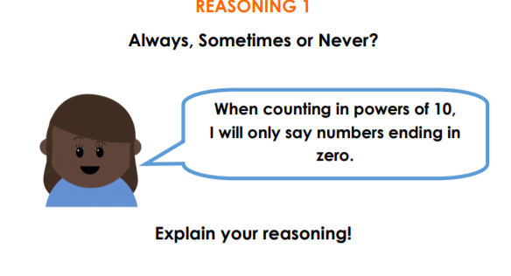

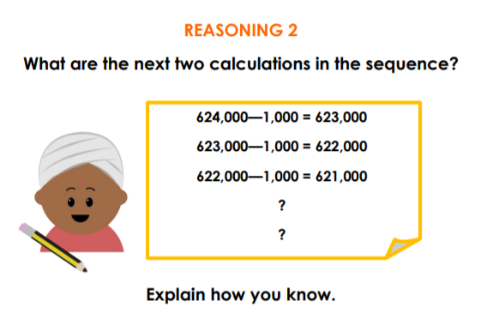

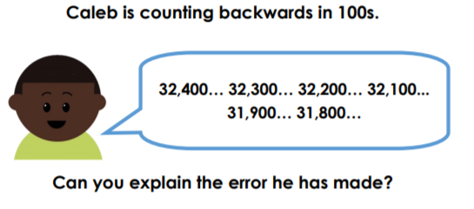

Problem Solving Task
Find as many different possible routes as you can. How can you do this in a systematic way?
