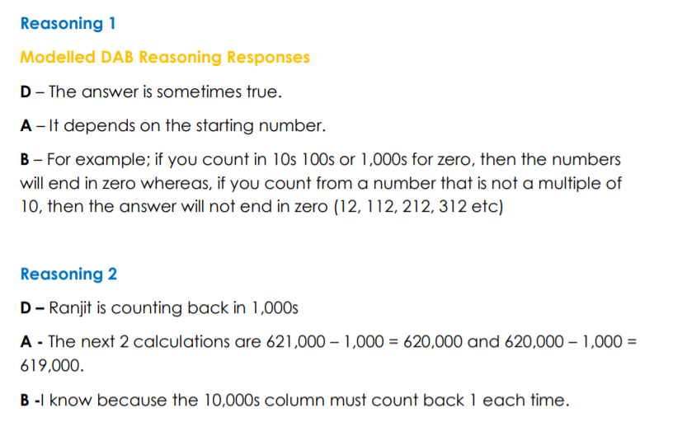
27.03.20 Maths Reasoning and Problem Solving Tasks: Counting in Powers of 10 Answers

