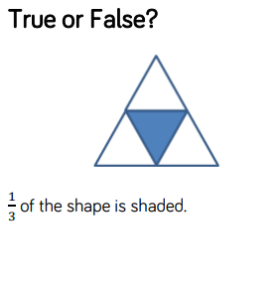
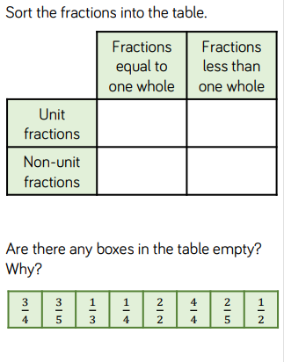
A non-unit fraction is a fraction where the numerator (the number on the top half of the fraction) is greater than 1. For example, 3/4 is a non-unit fraction, because three is the numerator. Children will come across non-unit fractions when finding fractions of an amount or of a set of objects.

