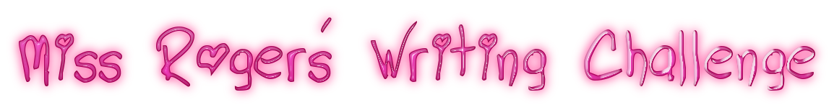
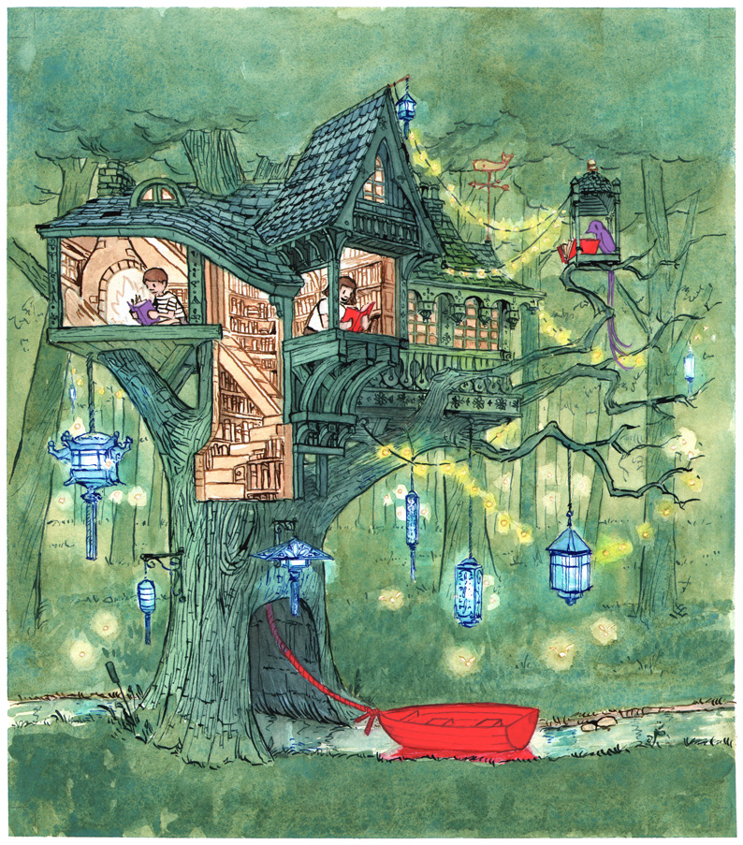

You can either draw this picture in your ‘home learning book’ or you can print off this picture.
Writing Challenge
Design your dream reading space. Where would it be? How would it be decorated? What reading material would you put in there (books, magazines, newspapers)? Which authors would you choose? How would you store the books? Would you allow other people to use the space?
Here are some questions to help you think about your dream reading space
- What makes this setting special?
- What would it sound like in this setting?
- What do you think the boy, girl and bird are reading?
- Do you think they enjoy reading?
- How long have they been here? How long will they stay for?
- Does anyone else know about this place?

You are all creative writers so have fun with this writing challenge!

