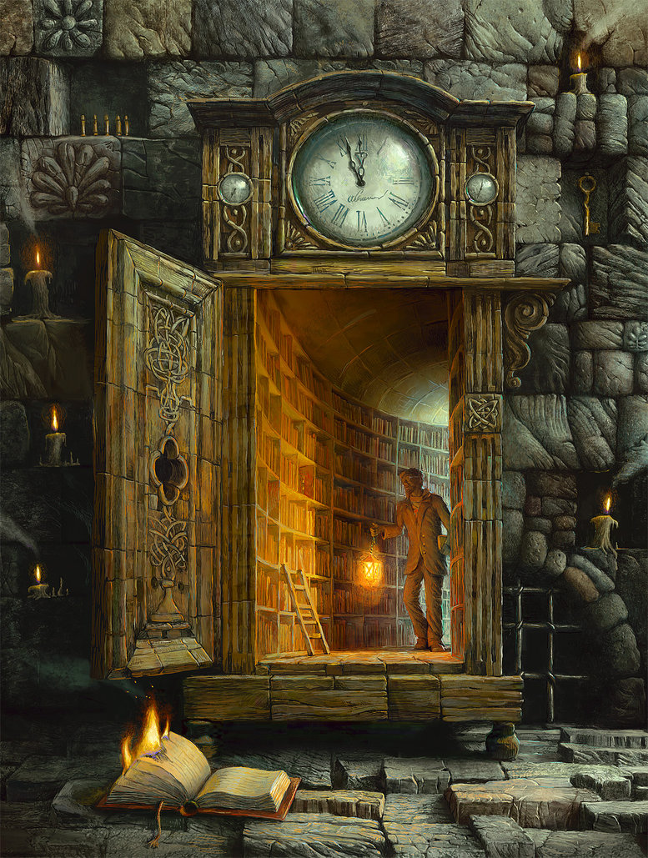
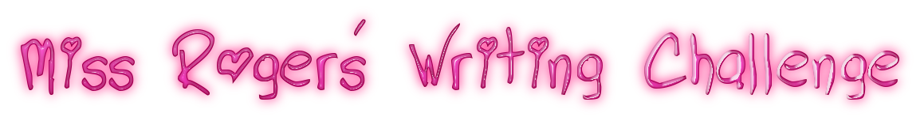
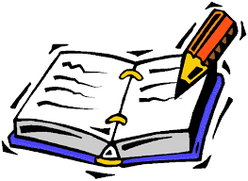

You can either draw this picture in your ‘home learning book’ or you can print off this picture.
“The Secret Passage”
Writing Challenge
Where does the secret passage lead?
Use these questions to help you write your short story
- What can you see? What do you think?
- How could you describe this setting? Consider the following:
  - What materials can you see?
  - The texture of each brick
  - The carvings, shapes and patterns
  - The level of cleanliness and the condition of objects
  - The light and shadows
You are all creative writers so have fun with this writing challenge!

