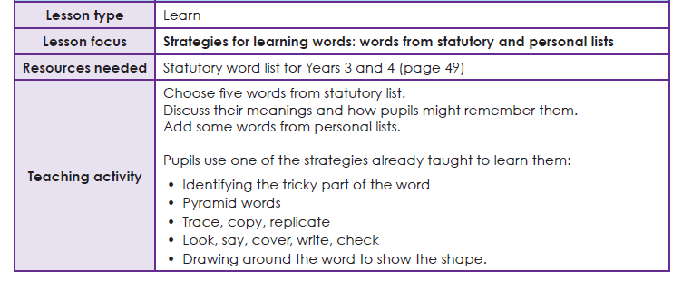
Year 3 Spelling list
Task 1 Learning your spellings
Use your ‘Spelling Journals’ to write the words from this list. You can use any spelling strategy to help you learn them.
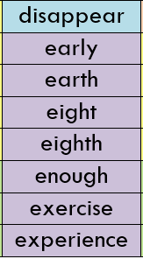

Task 2 Write into sentences
Write each of these words into a sentence. You could use more than one spelling word in the sentence. Give it a go! The more inventive the better!

