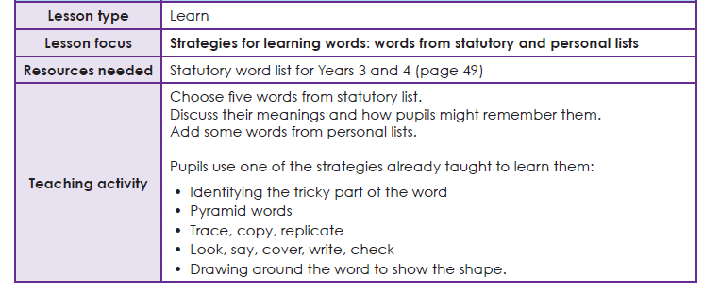

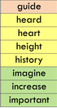
Task 1 Learning your spellings
Use your ‘Spelling Journals’ to write the words from this list. You can use any spelling strategy to help you learn them.

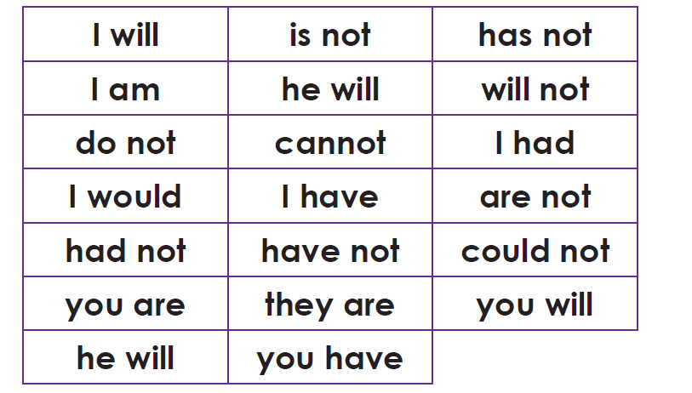
Task 2- Apostrophe for contraction