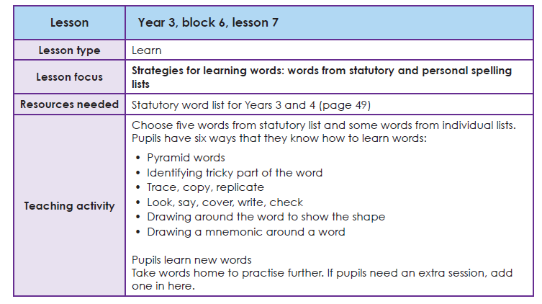

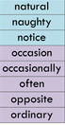
Task 1 Learning your spellings
Use your ‘Spelling Journals’ to write the words from this list. You can use any spelling strategy to help you learn them.

Task 2 Write these words into sentences
E.G. In Geography, we will be looking at natural disasters.
I often go for a walk with my dog when it is not too hot.

- Create sentences using one/both/all words. E.G.
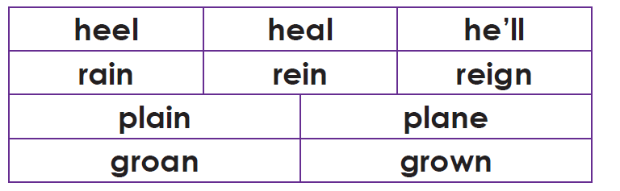
When water falls down from the sky, rain washes the earth, when a ruler dies, his reign is over and when a rider rides a horse, he straightens its reins.

