Tuesday 5th May 2020
Writing: Macbeth
What descriptive vocabulary have I used to describe the battle scene?
Your task:
- Watch Episode 1 The Weird Witches again. Listen very carefully for all the battle sounds you can hear such as cries, cheers, clanging armour….
List all the sounds you heard.

- Write a description of the battle scene on the heath.
In your work include:
- a description of the heath (using expanded noun phrases, similes and metaphors)
- a description of the battle using the sounds you collected before (use expanded noun phrases, similes, metaphors and onomatopoeia)
- direct speech between Banquo and Macbeth (remember to use inverted commas to punctuate this speech accurately).

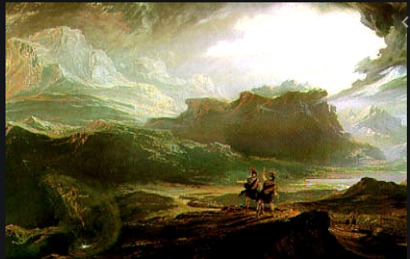

Use this picture to help you describe the heath if you need to.

