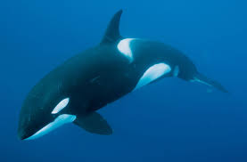
Thursday 7th May Whales (Non-fiction) Reading Comprehension
Questions
1. How long have whales been swimming in the oceans?
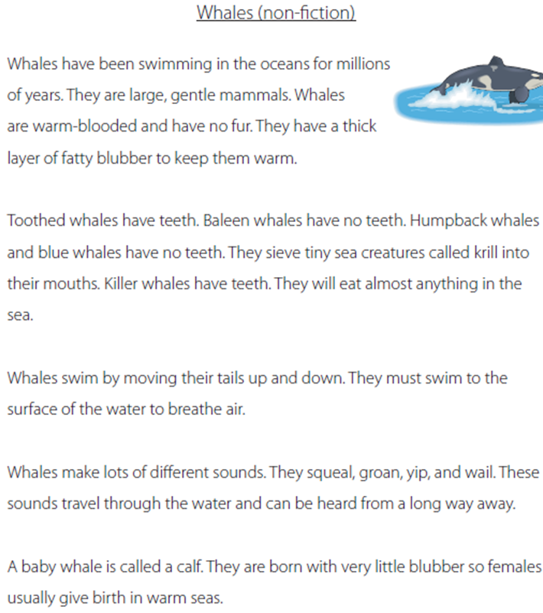
_________________________________________________

2. Are whales warm-blooded or cold-blooded?
__________________________________________________

3. Whales have a thick layer of fat. What is it called?
__________________________________________________

4. Blue whales feed on tiny creatures called:
a prawns
b seaweed
c krill
d ants

5. How do whales swim?
__________________________________________________

6. Why do whales swim to the surface of the water?

____________________________________________________

7. Write down three different sounds that whales can make.
_______________________
_______________________
_______________________

