What do we know about leaves?
In science this term we are learning about plants. When you go out for a walk or play in your garden collect at least five different leaves. Try to get leaves that are different looking.
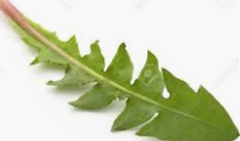 | 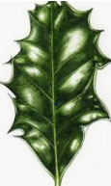 | 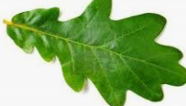 | 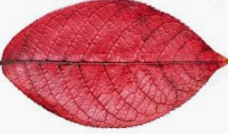 | 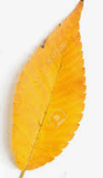
Can you name each plant? Make a name label for each leaf.
Maths:
Think about what is the same and what is different about the leaves. I could sort my leaves into smooth shapes and jagged shapes. Or green leaves and not green leaves. How many ways could you sort your leaves?
English:
Write two sentences using each of these sentence starters:
- Leaves are always…
- Leaves are sometimes…
- Leaves are never…
For example- Leaves are always from a plant. Leaves are sometimes yellow. Leaves are never stripy.
Spellings:
Learn these singular and plural spellings:
Singular | Plural
flower | flowers
plant | plants
leaf | leaves
shoot | shoots
seedling | seedlings
tree | trees
branch | branches

