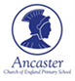
Home Learning Year 3 Topic activities
- Geography: Population, settlements, cities, villages, towns
- Science: Plants-experiments of transportation of water
- Art: Drawing, sketching, painting, junk modelling
- History: Shang Dynasty/Ancient Greece
- Class Identity ‘Class Tanzania’ Project
For your home learning, complete at least one activity per week, tick off once you have completed and be as creative as you like with your outcomes.
 | Activity | Completed
1. | Geography Make picture flashcards for these words and write the definitions: settlement, population, population density, distribution, linear, nucleated, dispersed, isolated  (use your Geography Knowledge Organiser for the definitions)
2. | Geography Design your own settlement  Pick a settlement (village, town or a city) and draw and label what would be in your settlement, i.e. Town- a hospital, shops, transport links (buses, trains)
3. | Geography Where in the world?  Choose a continent (Asia, Africa, Europe, North America, South America, Oceania, Antarctica) where you would want to live/currently live.  Write a fact file/Leaflet on your chosen continent, i.e. Asia is the most populous continent in the world, with 60% of the world’s population. Within Asia, China is the most populous country with 1.4 billion people. You can include pictures/draw pictures/facts from the internet/books/knowledge organiser
4. | Geography Design your own country  Currently there is 7.7 billion people in the world (and counting) We know by 2050 there will be over 9.6 billion people in the world. You need to design your own country to hold 1.9 billion extra people.  1) Name your country 2) Draw your country 3) Design buildings/shops/houses/transport for your country
5. | Science Design and draw a plant  Draw a plant/flower your choice, labelling each part of the plant/flower and explain what the function of each part of the plant/flower  i.e. fibrous roots are essential for the growth of a plant/flower as they absorb the water/nutrients from the soil and transport these through the stem to the leaves.
6. * | Science Perfect Plants Investigation  Look at different plants to observe the conditions they need to grow properly. See appendix *6
7. | Science What is the lifecycle of a flower?  Write a flowchart on the lifecycle of a flower. Remember each stage: seed, germination, seedling, fertilisation, pollination, seed dispersal.
7a. | Science How are seeds dispersed?  Write a leaflet on how seeds might dispersed from plant to plant/by water/by wind/by animal excretion.  Some plants disperse their seeds when the plant starts to wilt and the seeds falls off the plant onto the ground to restart the lifecycle of a plant.  Some seeds are dispersed when a seed falls off a plant/flower and animal eats it. Later, the animal excretes the seeds in a different place and the seed starts to grow.
8. | History What was life like in the Shang Dynasty?  Choose a social class: Shangdi, Emperor, Noble, Working. What would life be like for you?  Design a poster with illustrations, captions, headings, subheading, paragraphs etc (non-fiction report style)
9. | History Why was Cheng Tang a good emperor?  Design a poster about Cheng Tang (the 1st Emperor of the Shang Dynasty) and explain why he was a good ruler.  Draw a picture of Cheng Tang and interesting facts about him around the picture
10. | History What was the rise and fall of the Shang Dynasty?  Create a timeline from the start of the Shang Dynasty (1600 BCE- same time as the Bronze Age) to the end of the Shang Dynasty (1046BCE, when King Zhou was overthrown by the Zhou Dynasty)  On your timeline you can include all the dates you remember, different people we looked at during the topic. If you are stuck, look at 10* for the knowledge organiser.
11. | History Emperor design task  If you were an Emperor, how would you run your kingdom?  Draw a picture of you as an Emperor. How would you treat your people? Where would you live? What treasures would you have? What food would you eat? What clothes would you wear?
12. | History Project: Ancient Greece (term 5)  Next term we will be focussing on Ancient Greece. In preparation for this you need to write everything down you already know about Ancient Greece. Then, research away! Include pictures, captions, headings, subheadings etc. You may want to link it to the Olympics? Or the Greek Gods?  The aim of this task is to educate Miss Rogers on Ancient Greece!
13. | Art In the style of Andy Warhol  Look for items around your house that you could make a collage out of. EG. Sweet wrappers, tin foil. You can either draw them or stick these items onto card to make your collage. You can even find items in your cupboard to draw, like a tin of beans/soup.  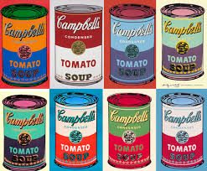
14. | Art Look out your window and draw what you can see. Spend some time looking at the details: flowers, insects, trees, leaves.  The more detailed the photo the better. Use colour to show the difference between the sky and the grass.
15. | Art In the style of Henry Moore.  Sketch a part of your body in detail, a hand is always a good one to sketch. Look at the detail on your hands, the lines on your palms, your fingernails.  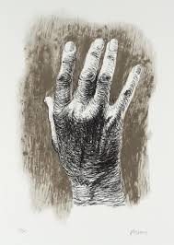
16. | Art What can you create?  Easter is on the way so can you create your own Easter card to send to your family or friends? The card can include Easter eggs, Easter bunnies, flowers or something to symbolise the resurrection of Jesus at Easter.
17. | Art A mirror image  Look at yourself in the mirror. What do you see? Draw your face, making sure you pick up on the details, i.e. the colour of your eyes, hair, skin tone.  You can use colouring pencils if you wish, or you could draw a pencil sketch version of yourself.
18. | Geography project-Class Tanzania  You have been in Class Tanzania now for nearly 7 months! WOW.  For your project you need to create a booklet on Tanzania about the wonderful things you will find there, i.e. the African animals, Mount Kilimanjaro, the native food, the population of Tanzania, which continent Tanzania is in. Remember to include the flag!  OR you can design your very own Tanzanian Tourist attraction Poster- You could draw the Serengeti desert and the animals would you find there, a safari tour to take people around the Serengeti. It is your choice!  -A booklet  -Or a Tourist Attraction Poster
19. | Save the Planet Project – Can you find three ways in which we can help the planet? It may be using less electric, reducing plastic consumption etc. Can you made a poster informing others of how to help?  Design a poster about how we can save the planet. Use our prefix words like recycle, reuse etc. Make this as colourful as possible to make it eye catching!  Together our ideas can save the planet!
20. | Inspirational Person Project – Tell me about an inspirational person to you? Are they famous across the world? Are they in your family or community?  Draw and write about this inspiration person. Why are they inspiration to you?

*6. | 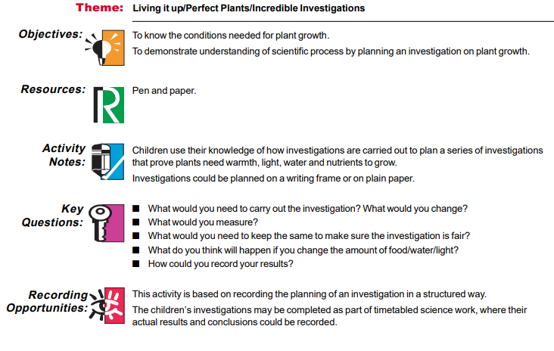  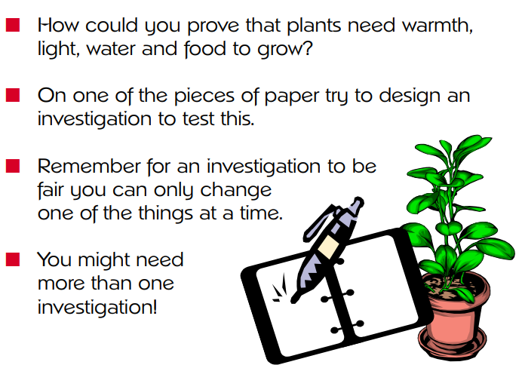
*10. | 