Summer Term 2020
Tuesday 21st April
Spelling Tasks- Year 5 and 6 common exception words
Words to learn: community, bargain, communicate, accommodate, committee, awkward, achieve, category, amateur and cemetery
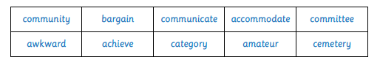
- Do you remember the meaning of these words from our Word of the Day sessions?

- Get an adult at home to give you a quick quiz on the words above to see how well you can spell them to give you a baseline score to beat.

- Place the words in alphabetical order in your blue book and write the definition for each word (either from your memory or using a dictionary). https://www.collinsdictionary.com/ is a good one to use if you prefer to use an online dictionary.

- Look at the words below. Which word of each pair is the correct spelling? Write this word 5 times as quickly as you can using joined and legible handwriting. (from each pair)
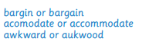

- Matching Pairs Game – Play with someone at home! The cards you need are attached on Parenthub.
- Place all of the cards face down on a table.
- You need to find the words that match.
- When you find the matching words, you need to say the word out loud and work out how many syllables there are in each word.
- The person with the most number of ‘pairs’ wins.
- Quick Activity – Write each sentence in your book with the correct word in each space.

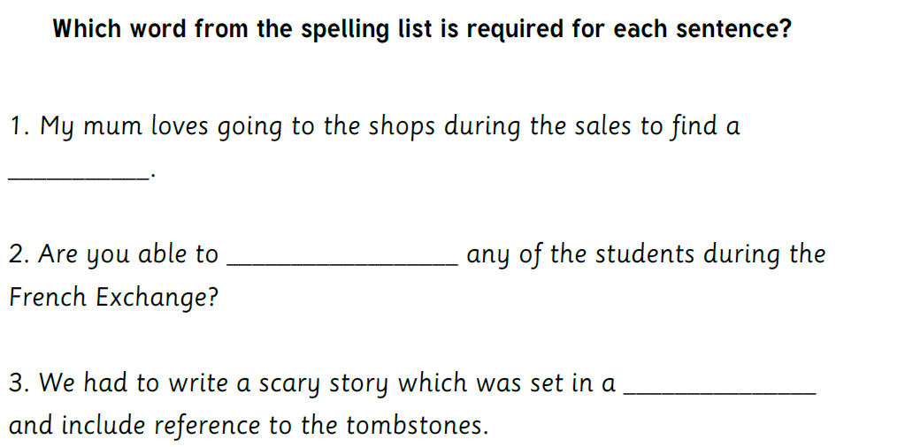

- Get an adult to give you a quick quiz again to see if you can beat your baseline score.

