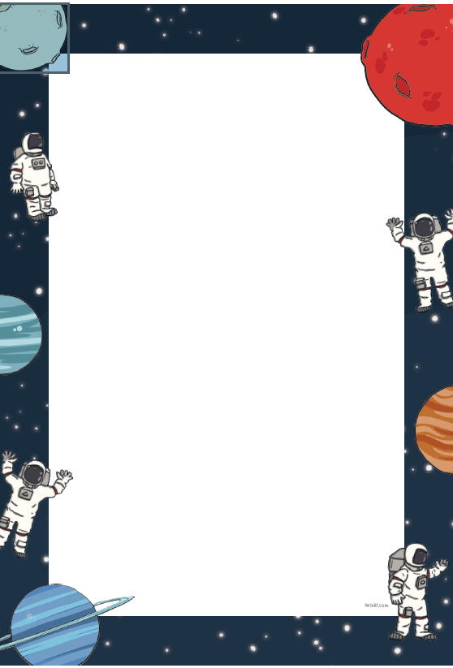

Make your own rocket

There are several different ways to make a rocket at home and largely depends on what materials you have at home. <https://www.digitaltrends.com/cool-tech/how-to-build-a-rocket/>

Here are a couple of suggestions:

Baking soda and vinegar rocket

You will need

* Baking soda
* Vinegar
* Paper towel
* Three pencils
* Tape
* Plastic drinks bottle

Plastic tubing rocket

You will need:

* Paper
* Plastic bottle
* Tube
* Scissors

<https://ioi.london/latest/new-video-make-your-own-paper-rocket-launcher/?gclid=EAIaIQobChMI_O3Si97e6QIVhrHtCh1rbQ7ZEAAYASAAEgKnCvD_BwE>

If you don’t have any of these materials, google ‘how to make a homemade rocket’ for lots more suggestions which use different materials.

Here’s some extra things to think about,

What would happen to your rocket if you change the bottle size or shape?

How could you change your rocket launcher so that you can stamp on the bottle to make your rocket go higher?

How can you change the shape of the wings to make it fly quicker?

What can you do to personalise your rocket with your own designs?