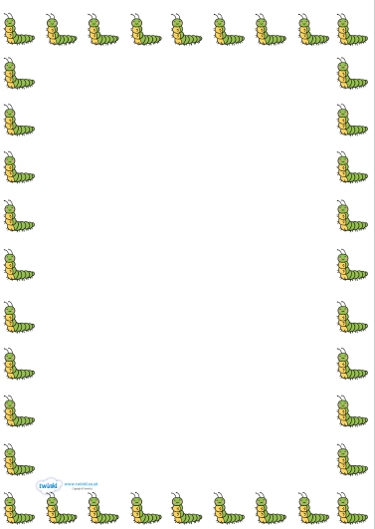

The Very Hungry Caterpillar

Read the story.

Have a go at spelling the days of the week, in order.

If today is Tuesday, yesterday was _________________

Tomorrow is Friday, so today is _____________

The days I don’t go to school are ______________ and _______________

If today is Monday, in two days time it will be _______________

After reading the story of The Very Hungry Caterpillar, what day did he eat a cake?

________________________________________